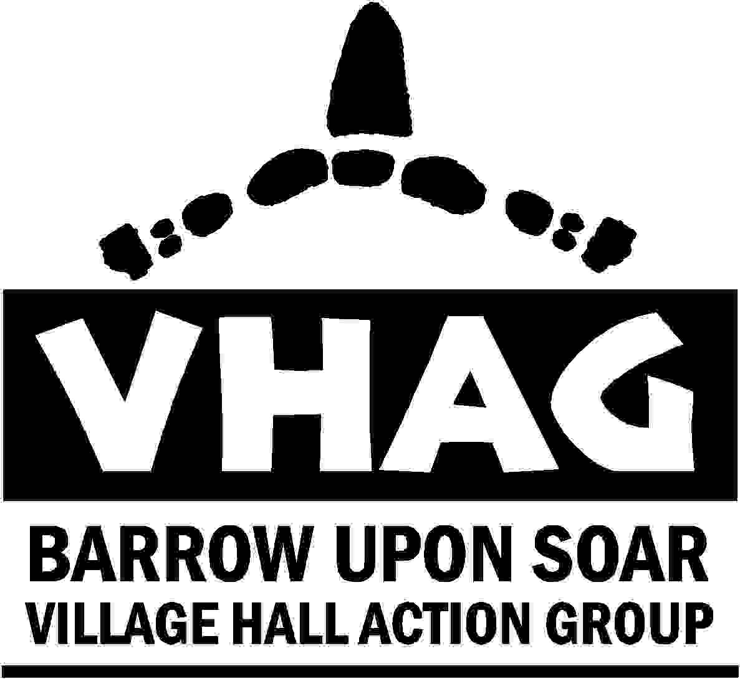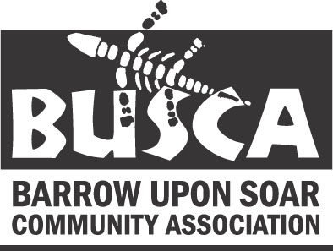
registered charity 505692 registered charity 505692

and
Arts and

Crafts Fair

10.30am until 4.30pm

North Street, Barrow upon Soar.

Craft Stalls. Exhibitions.
Bric-a-brac. Cakes.
Refreshments all day.
Cream Teas
50p admission

For further information or to book stalls contact
Sue Rodgers 01509 416533 or Jo 01509 412863

Proceeds to Barrow Community Association in aid of the Village Hall Fund

